2014/15 Annual Report of Oxford City Council’s Scrutiny Committee

September 2015

Chair and Vice-Chair’s Foreword

Everyone needs a ‘critical friend’ to offer advice, challenge and provide a second opinion on matters of importance. The City Council’s Executive Board (CEB), which makes most of the major administrative decisions, is no different.

The Scrutiny Committee, and the other half dozen Panels and Review Groups that it supervises, plays that role. We review reports prior to them being sent to CEB for a decision, promote new policy initiatives and suggest areas where we think the Council should be doing things differently.

This last Council year scrutiny has considered more than 60 reports and made in excess of 110 recommendations to CEB. We believe that a key indicator of our effectiveness is that more than 90% of the changes suggested by Scrutiny have been adopted in their entirety, or in part, by the CEB.

Of course, scrutiny would be nothing without the hard work of those elected Councillors that sit on the main Committee and on the many Panels and Review Groups that make up the Scrutiny function, as well as those members of the public that have chosen to get involved. It is their commitment to continuously improve the way Oxford City Council operates that has really made a difference.

One such councillor was Val Smith, who sadly left the City Council after serving her Blackbird Leys ward for 27 years and died this year after a long battle with cancer. With Val’s passing, the City Council, Scrutiny committee, and the Housing Panel she chaired with distinction since it was formed, all lost a valuable public servant. We want to record our affection and admiration for Val and her long years of service.

We would like to thank the many City Council officers who provided information and advice to scrutiny during the 2014/15 Council Year. Last, but not least, we would like to thank our exceptionally diligent Scrutiny and Committee Services Officers who are the glue which binds everything together.

Thank you.

`
Councillor Craig Simmons Councillor Tom Hayes
Chair, Scrutiny Committee Vice-Chair, Scrutiny Committee

Contents
Summary of scrutiny activity during 2014/15 3
About Scrutiny 4
Get involved 4
The Scrutiny Committee 5
Inequality Panel 6
Local Economy Review Group 8
Cycling Review Group 9
Finance Panel 10
Housing Panel 11
Recycling 12
Waste Water Flooding 12
The year ahead 13
Contact us 13

Summary of scrutiny activity during 2014/15

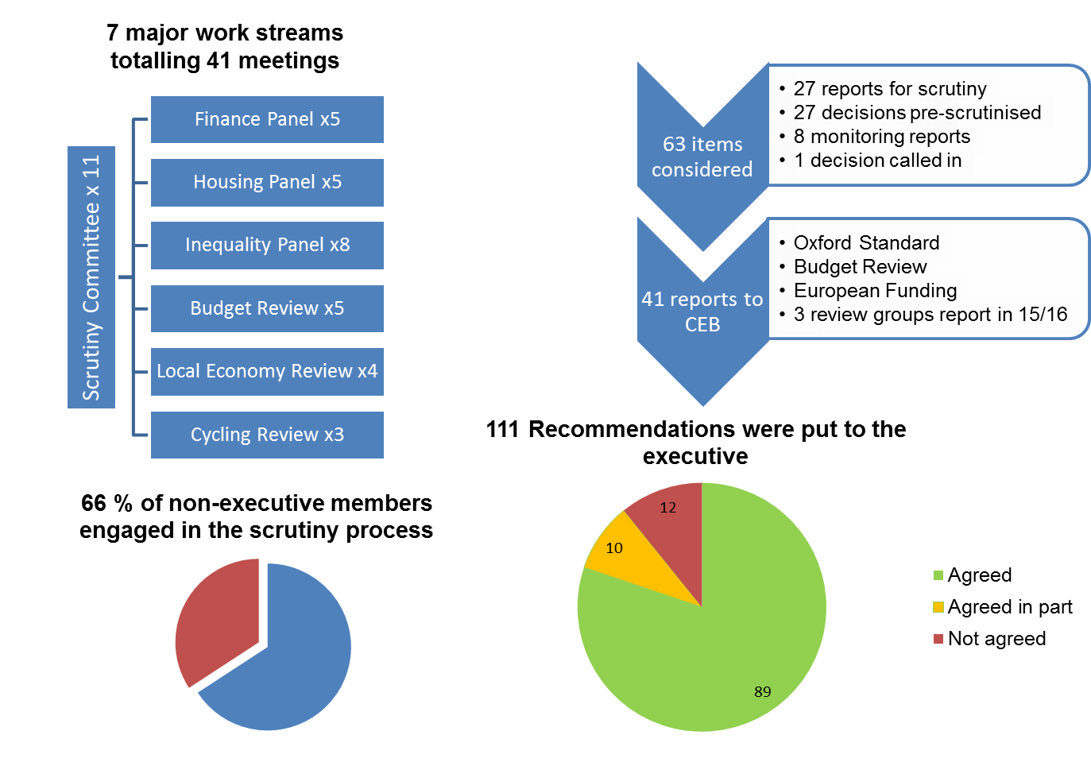

About Scrutiny

Oxford City Council operates an executive system where the 10 elected City Councillors on the City Executive Board are responsible for making most major decisions. Scrutiny provides a formal means for the remaining City Councillors to contribute to Council decision making and hold decision makers to account.

Scrutiny is empowered to question executive members and senior officers, and to make recommendations to them. Scrutiny can also investigate any issue affecting the local area, or its inhabitants, independently of the executive. In doing so, scrutiny can promote public engagement in democratic processes.

The work of scrutiny helps to provide assurance that the Council is performing well, providing value for money and taking the best decisions it can to improve public services and the quality of life for the residents of Oxford.

Scrutiny at Oxford City Council
Oxford City Council has a 12-member Scrutiny Committee which meets in public 10 times per year. The Committee has cross-party membership and is chaired by an opposition Councillor.

The Scrutiny Committee agrees an annual work programme which sets out the various topics and issues Councillors have chosen to focus on. The Committee also monitors decisions being taken by the City Executive Board throughout the year and looks at many of these in detail too.

Scrutiny can delegate work and responsibilities to two standing panels, which meet 5 times per year, and to time-limited review groups, which look at certain topics in detail.

“To ensure that Scrutiny operates independently, the Council’s Constitution requires that the Scrutiny Committee is chaired by an opposition member. In 2014, I was delighted to be elected to Chair Scrutiny (as well as being re-elected to Chair the Scrutiny’s Finance Panel). This report presents a review of the activities of Scrutiny during my first year in this role” – Cllr Craig Simmons, Chair, Scrutiny Committee

Call in
Call in is a statutory function that enables Councillors to challenge decisions that have been taken before they are implemented. If the call in request from 4 or more Councillors is deemed valid then the Scrutiny Committee will hear both sides of the argument and decide whether or not to refer the decision back to the decision maker.

Get involved
There are many opportunities for members of the public and representatives of groups and organisations to get involved in the work of scrutiny. You can:

- Attend meetings of the Scrutiny Committee, Standing Panels and some review groups, except in instances where confidential information is to be discussed. Details of these meetings are displayed in the Town Hall and on our website.

- Speak on any agenda item with the prior agreement of the chair by emailing democraticservices@oxford.gov.uk. Please give at least 24 hours notice. The chair will decide how long you can speak for.

- Suggest a topic for the scrutiny committee's work programme by completing and submitting our Work Programme Suggestion Form.

- Raise issues with your local City Councillor and request that scrutiny consider this as part of a Councillor Call for Action.

- Watch out for consultations, surveys and requests for evidence by registering at http://www.oxford.gov.uk/consultation

The Scrutiny Committee

Membership in 2014/15
Councillor Craig Simmons (Chair)
Councillor Tom Hayes (Vice-Chair)
Councillor Mohammed Altaf-Khan
Councillor Farida Anwar
Councillor Van Coulter
Councillor Roy Darke

Councillor James Fry
Councillor Sam Hollick
Councillor David Henwood
Councillor Ben Lloyd-Shogbesan
Councillor Linda Smith
Councillor Louise Upton

The Scrutiny Committee is responsible for the overall management of the Council’s Scrutiny function. This includes agreeing the issues and topics scrutiny focuses on during the year, setting up standing panels and review groups to look at priority topics in detail, monitoring decisions taken by the City Executive Board, agreeing recommendations to put to the executive, and monitoring the implementation of scrutiny recommendations.

This year the Committee decided to continue to have finance and housing standing panels, which considered all issues and decisions that fell within their remits. It also established three review groups which looked in detail at issues of inequality, the local economy and cycling.

In addition, Scrutiny Councillors continued engagement with Thames Water Utilities over the issue of sewerage flooding in Oxford, and kept a close eye on recycling rates in the city through less formal groups that met on an ad hoc basis.

The remainder of the work of scrutiny took place at meetings of the Scrutiny Committee.

Improving Council performance
The Committee monitored the Council’s quarterly performance and received an annual report on the performance of the Council’s leisure partner, Fusion Lifestyle.

The Committee also questioned the Council Leader and Chief Executive following a Local Government Association peer review exercise. The peer challenge team concluded that Oxford City Council is a good council delivering some impressive outcomes. It also highlighted some ways in which the Council could improve further. One such suggestion was that scrutiny could have a more proactive improvement focus and act as a conduit for communities of interest. The Committee developed the Council’s scrutiny function in these respects in response to this feedback.

Scrutinising public services
The Committee scrutinised a number of Council services and functions during the year, including; activities for older people, street cleaning, community and neighbourhood services, the move to individual voter registration, community engagement and consultation, and the Council’s educational attainment programme. These discussions all resulted in recommendations to the executive.

The Committee also decided to monitor the work of the Oxfordshire Growth Board. This is a joint committee comprised of representatives of Oxfordshire Councils and a range of other partners that was set up in 2014 to deliver projects agreed in the City Deal - an investment programme that aims to promote innovation-led growth in the Oxfordshire economy.

Monitoring executive decisions
The Committee scrutinised a number of Council decisions before they were taken, and reported its findings and recommendations to the City Executive Board (CEB). These included decisions about the Council’s safeguarding policy, culture strategy, statement of community involvement in planning, grant allocations to community and voluntary groups, and an action plan for improving the Covered Market. The Committee also considered one decision taken by CEB that was ‘called in’ by Councillors. This covered the Sale of Temple Cowley Swimming Pool.

Inequality Panel

Membership
Councillor Van Coulter (Chair)
Councillor Andrew Gant
Councillor Ben Lloyd-Shogbesan
Councillor David Thomas

The Inequality Panel was set up to examine a number of related topics Councillors wanted to focus on, such as; food poverty, child poverty and health inequalities. This panel was led by Councillor Van Coulter and it conducted the biggest piece of review work commissioned by the Scrutiny Committee during 2014/15.

In order to tackle this wide ranging topic in a manageable way, the Panel focused on ways in which the City Council can make the most difference in combatting inequality. It sought to highlight gaps in provision and opportunities for the City Council to do more.

The Panel invited representations from groups and individuals by issuing a call for evidence, which received local press attention. 30 responses were received and a number of respondents were invited to provide evidence at public meetings.
The Panel found considerable evidence that the very high cost and limited supply of housing is a major driver of inequality and makes it extremely difficult for most people to settle in the city. Although the housing crisis is exacerbated by welfare reforms and relatively low wages, it affects everybody in the city, including high and middle earners, in a variety of ways.

The Panel’s report, including 21 wide-ranging recommendations, was published in July 2015. The City Executive Board agreed to consider the Panel’s recommendations over the summer and consult with opposition groups before publishing a full response in autumn 2015.

“We know that there are large differences in life expectancy between the most privileged and the most disadvantaged social groups living in Oxford. A seismic shift needs to happen. This requires ambition matched by innovation, led with political commitment to improve well-being, mental health and life-chances – directed at addressing the causes of poverty” – Cllr Van Coulter, Chair, Inequality Panel

Key recommendations called for:

- Innovation in the provision of affordable housing
- More key worker housing
- Interventions in the private rented sector to improve standards
- Action to address food poverty
- The creation of an Oxford Living Wage hub
- A new educational attainment fund

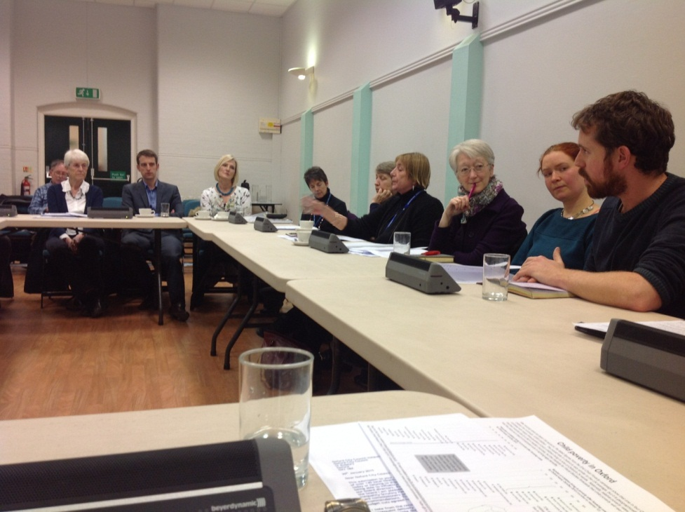
Witnesses provide evidence to the Inequality Panel in March 2015

Local Economy Review Group

Membership
Councillor James Fry (Chair)
Councillor Elise Benjamin
Councillor Roy Darke
Councillor Mike Gotch

The Local Economy Review Group was led by Councillor James Fry and focussed on supporting businesses in the city centre at a time when major developments in strategic locations were beginning to affect the trading environment.

The Group looked at ways in which the City Council could help to mitigate disruption to retailers, particularly those in the independent sector. It also considered the issue of empty shop units and whether these could be re-let more quickly, including their possible use pop-up shops.

The Group supported moves towards a Business Improvement District (BID) in Oxford city centre, which is a business-led partnership that funds additional resources or services through a levy on Business Rates. The Group also welcomed a variety of initiatives that were already being led by the Oxford Town Team, a partnership of city centre businesses and public sector organisations.

The Group received a number of helpful suggestions from the City Centre Manager, members of the Oxford Town Team and commercial landlords as to how City Council could build on this work and help to make the city centre even more attractive to both retailers and shoppers.

The Group published a report in May 2015 with 10 recommendations for the executive to consider, of which 5 were agreed. The Group will reconvene in early 2016 to monitor progress and review the business case for a BID.

Key recommendations called for:

- The development of a comprehensive long term strategy for the city centre
- A single united channel of communication to businesses
- An overall marketing campaign for Oxford
- A forum to bring together commercial landlords

Cycling Review Group

Membership
Councillor Louise Upton (Chair)
Councillor Andrew Gant
Councillor Susanna Pressel
Councillor Dick Wolff

The Cycling review Group was led by Councillor Louise Upton and considered how the City Council could make best use of its unallocated capital budget for cycling improvement schemes, which totalled £110k over two years.

The Review Group met with representatives of cycling groups, a transport planning researcher and Council officers before drawing up a wish-list of priority projects. The Group’s highest priority was signage on the East Oxford route from the Plain to Blackbird Leys via Iffley Road and the Cowley Centre. The Group cycled this route with officers to highlight where signage and other improvements were needed.

The Group looked at how the City Council could improve cycling provision through developer contributions, planning policy and the option of having an abandoned bicycle refurbishment scheme.

Mindful that the County Council was developing a new transport strategy, the Group went further by recommending how the City Council could work with partners to make its vision for Oxford to become one of the great cycling cities of Europe a reality. The Group suggested that this should involve; bringing the cycling lobby together within a single forum, agreeing a set of specifications for cycle infrastructure design, agreeing a consistent standard for cycle signage, and aiming to achieve a £10 per head of population investment in cycling.

The Group also considered the case for the City Council to employ a dedicated cycling officer, and highlighted some of the benefits that such a role could bring. The Group’s report and recommendations were published in August 2015.

“Every person that we can get out of a car and on to a bicycle is good for Oxford, good for the environment and good for them. We need to encourage it every way possible and we must spend every pound wisely. Our report aims to make that happen” – Cllr Louise Upton, Chair, Cycling Review Group

Key recommendations called for:

- The Group’s wish-list of cycling improvement schemes to guide future investment decisions
- A partnership approach to developing an overall cycling strategy for Oxford
- A dedicated cycling officer
- Consideration of cycling provision in all major planning decisions

Finance Panel

Membership in 2014/15
Councillor Craig Simmons (Chair)
Councillor Roy Darke
Councillor Jean Fooks
Councillor James Fry

The Finance Panel, chaired by Councillor Simmons, was responsible for reviewing and monitoring the Council’s financial performance and treasury management function throughout the year. The Panel also kept a close eye on recommendations taken up by the executive, including improvements to the management of the Council’s capital programme and the adoption of an ethical investment policy.

The Panel conducted a detailed review of the Council’s annual budget and medium term financial plan over the New Year period, finding the Council’s spending plans to be balanced, robust and supportive of its Corporate Plan priorities. The Panel made 17 recommendations aimed at strengthening these proposals and mitigating financial risks.

In February, the Panel convened a discussion about maximising the benefits of European Funding, which benefited from contributions by South East Members of the European Parliament. This resulted in 9 recommendations to the executive. These highlighted opportunities to work more closely with Oxford’s Twin Towns and local businesses on joint funding bids, and suggested some priority issues for such bids, including; housing, low carbon, sustainable transport, recycling and improving air quality.

The Panel also met with a representative of the Municipal Bonds Agency to look at the case for investing in, or borrowing from, the Agency. The Panel recommended that the City Council should consider becoming a minimum shareholder in the Agency in order to secure preferential interest rates on future borrowing.

"Finance Panel helps keep the Council on a sound financial footing by challenging new budget proposals, monitoring progress against existing targets, and exploring innovative fund-raising models and novel, cost efficient, approaches to service delivery" – Councillor Craig Simmons, Chair, Finance Panel

Looking ahead
The Finance Panel will continue to focus on developing Council policy by looking at whether the funding model used by the Low Carbon Hub could be replicated to generate capital financing, for example to build housing. The Panel will also look at Council Tax exemptions, conduct a detailed annual review the Council’s budget proposals and monitor financial performance through the year. Councillor Tom Hayes has replaced Councillor Roy Darke on the Panel for 2015/16.

Housing Panel

Membership in 2014/15
Councillor Sam Hollick (Chair)
Councillor Gill Sanders
Councillor Linda Smith
Councillor Liz Wade
Linda Hill, Tenant Co-optee

The Housing Panel is responsible for scrutinising the City Council’s housing functions and all executive decisions relating to housing. In 2014/15 the Panel comprised 4 City Councillors and a Council tenant, Linda Hill. It was led by Councillor Sam Hollick following the resignation from Council of the late Val Smith.

The Oxford Standard review, which was co-chaired by Councillor Smith and the chair of the Tenant Scrutiny Group, reported in June 2015 and its recommendations were largely agreed and implemented by the executive. This review involved engaging with tenants to define a local standard for social housing beyond that required by the national Decent Homes Standard.

Some important housing decisions were considered by the Panel including a long-term housing strategy and a new asset strategy for the Council’s housing stock, which included the Oxford Standard. The Housing Panel joined with the Finance Panel, where appropriate, to scrutinise the finances and business plan for the Council’s Housing Revenue Account.

The Panel scrutinised a number of local housing issues at panel meetings, including; illegal dwellings, under-occupation, fuel poverty, tenant satisfaction, rent arrears, and homelessness services. Following on from a previous recommendation, Housing Panel members were invited to visit a number of City Council-run parks.

Looking ahead
The Housing Panel is continuing into 2015/16 with a new Chair, Councillor Linda Smith, and a new tenant representative, Geno Humphrey. Its membership has increased from 4 to 6 Councillors, with the addition of Councillor Elise Benjamin and Councillor David Henwood. The Panel plans to look at a variety of issues including the involvement of tenants in decisions that affect them, Council actions to address homelessness and the Choice Based Lettings system for allocating social housing. A number of housing decisions will also be scrutinised by the Panel including a new Private Sector Housing Policy, a review of the licensing scheme for Houses in Multiple Occupations, and a review of the provision of sheltered housing in Oxford.

“Building more affordable homes, providing a first class service to our existing tenants, improving standards in the private rented sector and fighting homelessness are high priorities for this council. The Housing Panel will act as a critical friend to scrutinise the efforts being made in these areas to help ensure that, whatever policies and budgets come from national government, Oxford City Council will continue to deliver the best possible results” – Cllr Linda Smith, incoming Chair, Housing Panel

Recycling

Membership
Councillor James Fry (Chair)
Councillor Tom Hayes
Councillor Craig Simmons

Councillor James Fry chaired a review group looking at recycling rates which reported in July 2014. This report recommended that the City Council invest in targeted recycling education campaigns and trial a community incentive scheme to encourage residents to recycle for charity. Following this review, the City Council successfully bid for a substantial government grant to be used on a recycling incentive scheme covering the whole city. Scrutiny has continued to monitor the Council’s progress at boosting recycling rates.

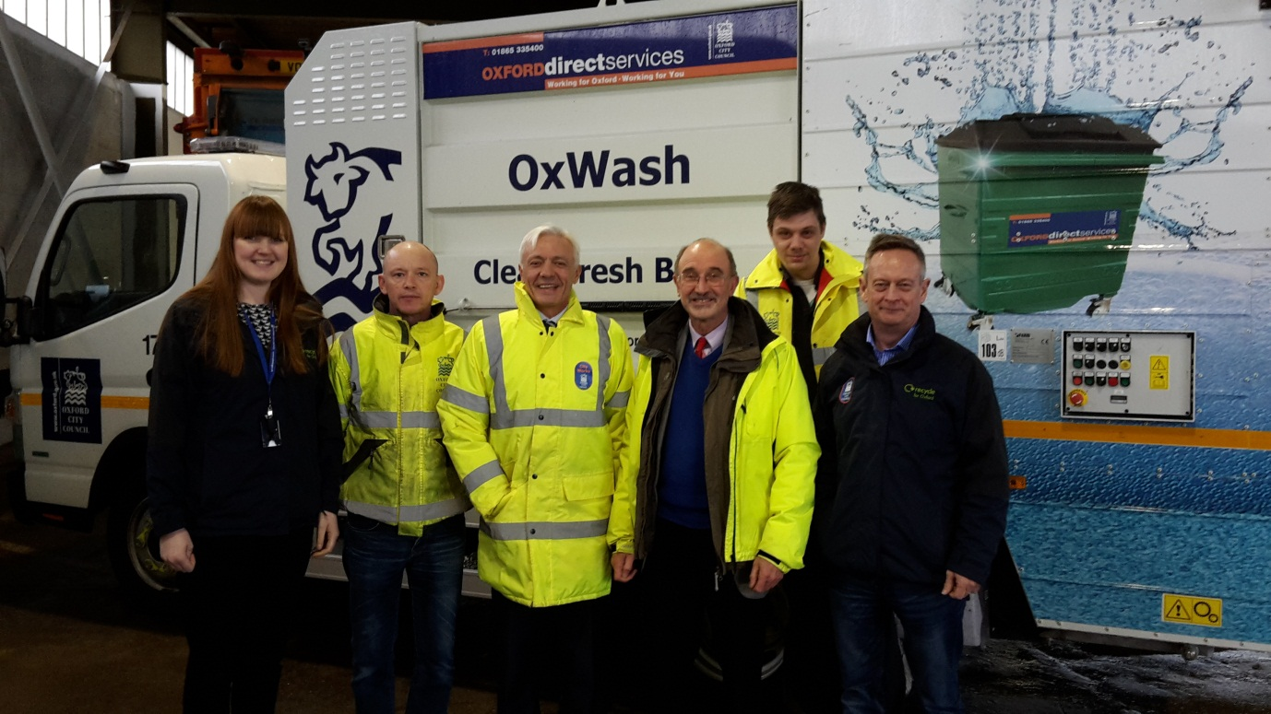
Councillor Fry (third from right) visits the Council’s waste and recycling team in February 2015

Waste Water Flooding

Membership
Councillor Roy Darke (Chair)
Councillor Steve Goddard
Councillor Susanna Pressel
Councillor David Thomas

Councillor Roy Darke convened a meeting with representatives of Thames Water Utilities (TWU), local MPs and Oxford Flood Alliance in May 2014 to seek agreement to address the issue of frequent sewerage flooding in parts of the city.

TWU agreed to bring forward a major catchment study of Oxford’s sewerage system in order to identify issues and priorities for future investment. This would be preceded by a smaller pilot study in the Grandpont area.

A further meeting was held in July 2015 where a Panel of Councillors welcomed the progress that had been made and the find and fix approach being taken, which already seemed to be making a noticeable difference in ameliorating some of the pressure on the city’s sewerage network.

“Improvements to the workings of the sewerage network are vital at a time when the city’s population is increasing and a major new housing development is being built at Barton Park” – Cllr Roy Darke, Chair, Waste Water Flooding Group

The year ahead

The Scrutiny Committee is continuing to develop and improve the Council’s scrutiny function based on feedback received in a survey of Councillors, as well as external advice. This includes strengthening the monitoring of recommendations, seeking to involve more Councillors in the scrutiny process, and learning from best practice at other local authorities.

Two new Councillors have joined the Scrutiny Committee for the 2015/16 municipal year. Councillor Sian Taylor and Councillor Andrew Gant have replaced Councillor Farida Anwar and Councillor Mohammed Altaf-Khan respectively.

The Scrutiny Committee has agreed to establish a review to look at the case for a voluntary code of practice to improve safeguarding in guest houses. A one-off Panel will meet to scrutinise the decision to implement a city centre Public Spaces Protection Order. Equality and diversity is another high priority topic for the Committee.

Contact us

Scrutiny Officer, St. Aldate’s Chambers, 109 St. Aldate’s, Oxford, OX1 1DS; tel: 01865 252230; email: democraticservices@oxford.gov.uk

